**Hands on Exercise**

You will configure horizontal navigation with an unordered list in this Hands-On Practice. Create a folder named ch7hort. Copy the files lighthouseisland.png, lighthouselogo.png, and starter4.html from the chapter7 folder in the student files into your ch7hort folder. Display the web page in a browser. It should look similar to [**Figure 7.25**](https://jigsaw.vitalsource.com/books/9780133971026/epub/OPS/xhtml/fileP70004950620000000000000000021C0.xhtml#P700049506200000000000000000220B)—notice that the navigation area needs to be configured to display in a single line.

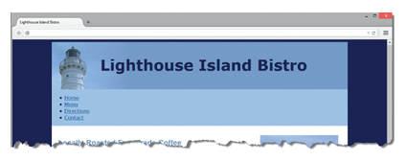

**Figure 7.25 *Notice that the navigation area needs to be configured.***

Launch a text editor and open the starter4.html file. Save the file as index.html in your ch7hort folder.

1. Examine the nav element and notice that it contains an unordered list with navigation hyperlinks. Let’s add CSS to the embedded styles to configure the unordered list element within the nav element: eliminate the list marker, center the text, set the font size to 1.5em, and set the margin to 5 pixels.

nav ul { list-style-type: none;

text-align: center;

font-size: 1.5em;

margin: 5px; }

1. Configure the list item elements within the nav element to display as inline elements.

nav li { display: inline; }

1. Configure the anchor elements within the nav element to display no underline. Also set the left and right padding to 10 pixels.
2. nav a { text-decoration: none;

padding-left: 10px;

padding-right: 10px; }

Save your page and test it in a browser. Your page should look similar to [**Figure 7.26**](https://jigsaw.vitalsource.com/books/9780133971026/epub/OPS/xhtml/fileP70004950620000000000000000021C0.xhtml#P7000495062000000000000000002222).

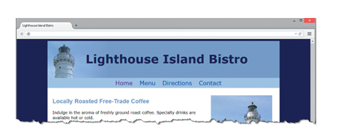

**Figure 7.26 *Horizontal navigation within an unordered list.***